RESOLUTION NO.__________

RE: CERTIFICATE OF APPROPRIATENESS UNDER THE
PROVISIONS OF THE ACT OF THE PENNSYLVANIA
LEGISLATURE 1961, JUNE 13, P.L. 282 (53
SECTION 8004) AND BETHLEHEM ORDINANCE NO.
3952 AS AMENDED.

The applicant proposes to install hanging lights in the North Green of the Sun Inn and install 3 lantern style lights on posts at 564 Main St.

NOW, THEREFORE, BE IT RESOLVED by the Council of the City of Bethlehem that a Certificate of Appropriateness is hereby granted for the proposal.

Sponsored by: (s)

(s)

ADOPTED BY COUNCIL THIS DAY OF

(s)
President of Council

ATTEST:

(s)
City Clerk

HISTORICAL & ARCHITECTURAL REVIEW BOARD

This is a re-submission regarding hanging lights and lanterns from the April 2018 HARB meeting with additional details and fixture selections at the Sun Inn at 564 Main St.

APPLICATION #2:

Sun Inn Preservation Association
564 Main St.
Bethlehem, PA 18018

OWNER:

__________________________________________________________________________

The Board upon motion by Phil Roeder and seconded by Marsha Fritz adopted the proposal that City Council issue a Certificate of Appropriateness for the following:

- To suspend cable lighting and install 3 lantern lights on posts at the North Courtyard.

2. The motion was unanimously approved.

__________________________________________________________________________

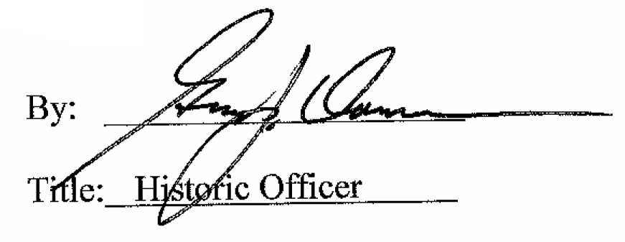

Date of Meeting: May 2, 2018

